Katie Hawthorne
COMP 116
20 November 2009
Assignment #7
Scripts used:
dataCollection: contains the script used to collect data
dataAnalysis: contains the script used to analyze data
Hypothesis:
My hypothesis is that it will take longer to type incorrectly spelled words than it will take to type correctly spelled words.
Experimental Procedure:
My experimental procedure is that I have compiled a list of 54 correctly spelled words, and 54 incorrectly spelled versions of the same words used for the correctly spelled list. I then created a for loop that will run for 100 rounds and it will randomly select either a correctly or incorrectly spelled word to print for the user to type. If the user types the word correctly, the time will be saved. If the user types the word incorrectly, it will not be saved. I then analyzed it by creating a histogram, and I plotted the resulting normal distribution expected from the mean and standard deviation of the times for both the correct and incorrect data sets.
Results:
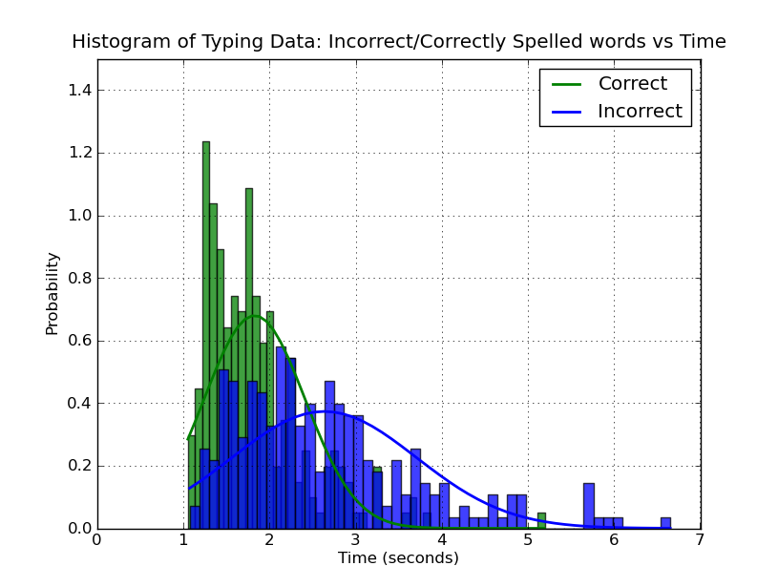
As shown by the resulting histogram, the correctly spelled words do have a much narrower distribution than the incorrectly spelled words, and the concentration of data points for the correctly spelled words is thus much lower in time than the incorrectly spelled words, which have a larger distribution and a higher mean time than the correctly spelled words. From this data, I would assume that my hypothesis is supported.

